**VALENCY DICKSON**

A **Front end Developer** based in Dar es Salaam

Tanzania.

**Date of Birth**: *29th March 1995* | **Sex**:*Male* **| Marital Status**: *Single*

icons8-speaker-phone-50.png[**(+255) 788 035 718**](tel://+255788035718) **| icons8-gmail-100.png** [**dickson.valency@gmail.com**](mailto:dickson.valency@gmail.com) **| ** [**Valency-dickson**](https://www.linkedin.com/in/valency-dickson-0a7754125/)

**Introduction:**

Hi, I’m a self taught web developer; I have serious passion for website and web app design and development. I consider myself a person who is trustworthy, responsible, respects deadlines and knows that customer’s satisfaction is the key to success.

I'm always open to learn and try something new in web development. I’m a fast learner, able to pick up new skills and juggle different projects and roles

**Education:**

|  |  |
| --- | --- |
| **Udemy** (Online course) |  |
| Awarded: The complete 2020 Web Development Bootcamp. | *Mar. 2020 - Dec.2020* |
|  |  |
| **Ardhi University** | Dar es Salaam, Tanzania |
| Awarded: BS. In Geomatics Engineering. | *Oct.2014 – July.2018* |
|  |  |
| **Minaki High School** | Pwani, Tanzania |
| Awarded: Advanced Certificate of Secondary Education. | *Apr.2012 – May.2014* |
|  |  |
| **Benjamini William Mkapa High School** | Dar es Salaam, Tanzania |
| Awarded: Certificate of Secondary Education. | *Jan.2008 – Oct.2011* |

**Technical Skills:**

|  |  |
| --- | --- |
| -HTML5 | -CSS3 |
| -JavaScript | -Bootstrap |
| -jQuery | -Adobe Illustrator |
| -React | -WordPress |
| -Git/GitHub | -VsCode |

**Soft Skills**

|  |
| --- |
| -Efficient and effective communication skills |
| -Self-organized and able to work independently |
| -Passion and hunger for excellence |
| -Motivated to take on new challenges |
| -Great time management for faster and efficient work |

**Experience:**

|  |  |
| --- | --- |
| **Self-Employed** | Remote |
| FRONT-END WEB DEVELOPER | *Aug.2020 - Present* |
| As a freelance frontend developer I had a chance to work with several clients remotely.   * I have created responsive websites, web apps and landing pages. * Designed & developed custom WordPress websites with both ready-made themes and custom themes coded from scratch. |  |
| **Independent Planners Limited** | Dar es Salaam, Tanzania |
| GEOMATICIAN / GIS ANALYST | *Sept.2018-Feb.2020* |
| As a Geomatician / GIS analyst, I was involved in designing, conducting and managing some projects including Land Formalization, Cadastral Surveying, and Engineering Survey.   * Establishing ground control points to be used in surveying works. * Designed layout of the roadway, set the centre lines and cuts and fills for grading. * Topographic survey to determine contours and both natural and man-made features along the road. * Conducted and ensured demarcation of surveying plots and coordination of plots then beacons erection. * Prepared cadastral data from field, drawing cadastral plans and compilation of cadastral file. |  |

**Side Projects:**

I have conducted several side projects which they are in my GitHub account ([Valency dickson](https://github.com/valencydickson)).

* Responsive Loopstudio Landing Page

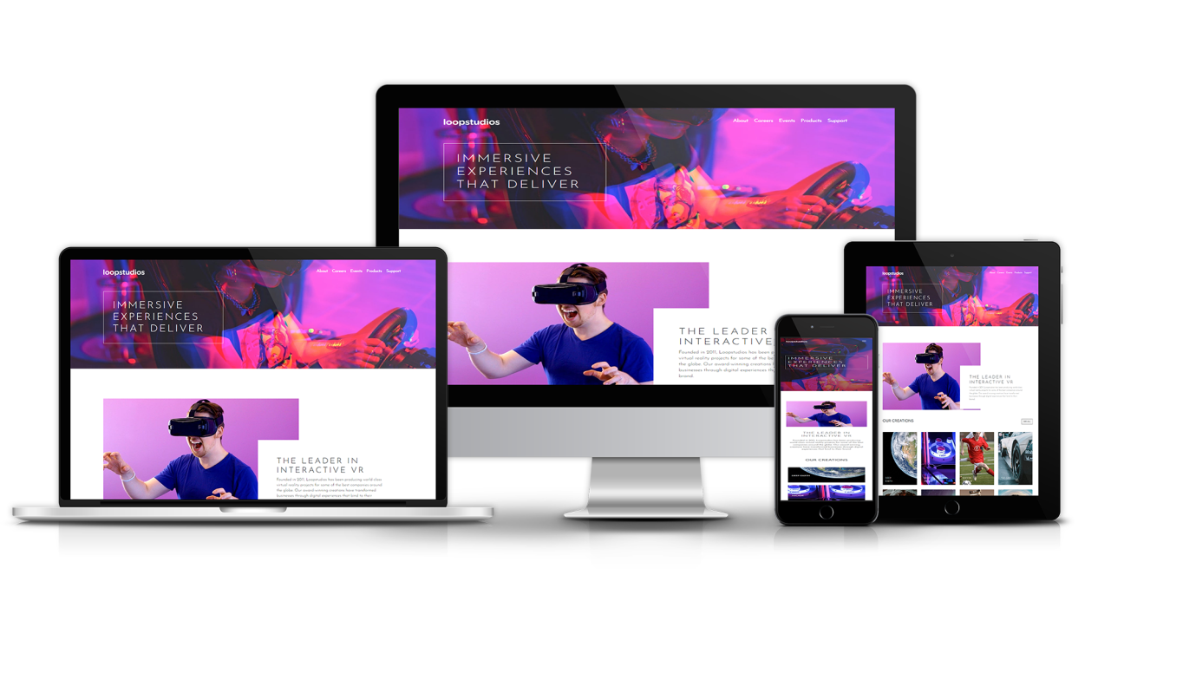

Source code:

|  |
| --- |
| Languages |
| HTML5  CSS3  React Js |

|  |  |
| --- | --- |
|  |  |
|  |  |
|  |  |
|  |  |
|  |  |
|  |  |
|  |  |
|  |  |
|  |  |

**Certificates:**

